**GROUP ASSIGNMENT**

(KHUSHI SHAH, DHRUVI VIRANI,JYOTI PRAJAPATI)

1. Made folder named GroupAssignment and created three files in that particular folder

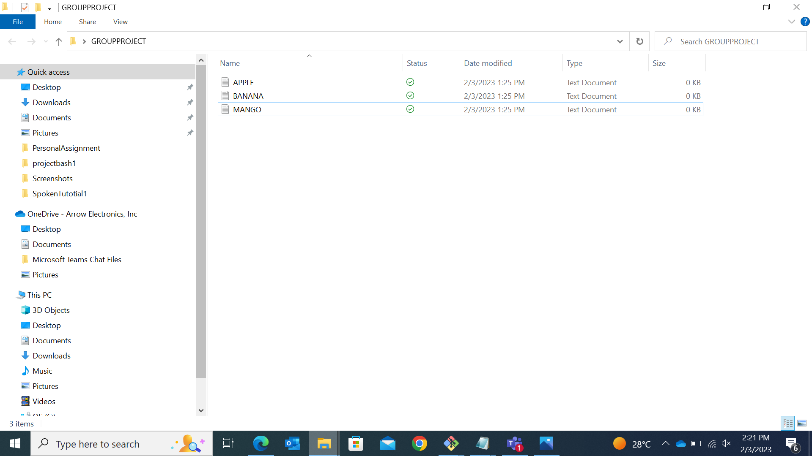

Made an account into the GitHub and created a new repository into it.

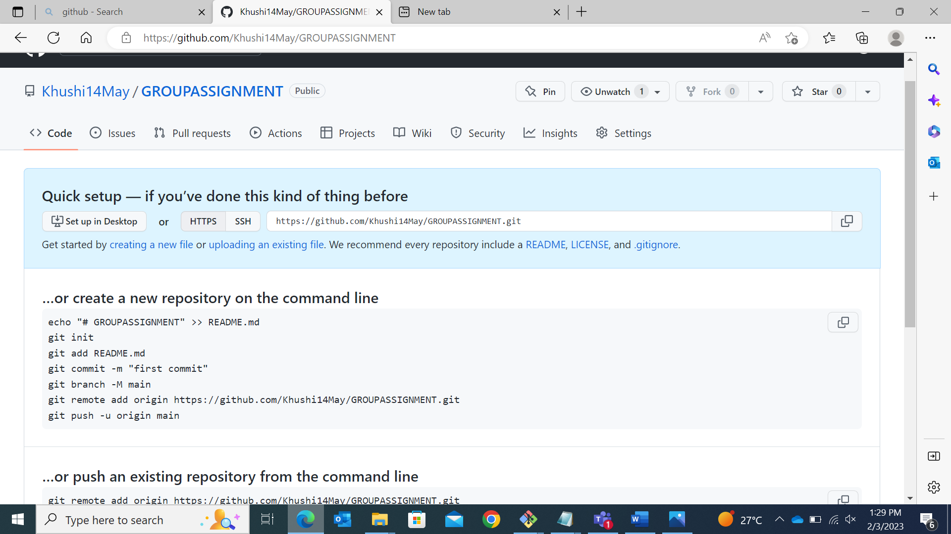

Added the files to the repo

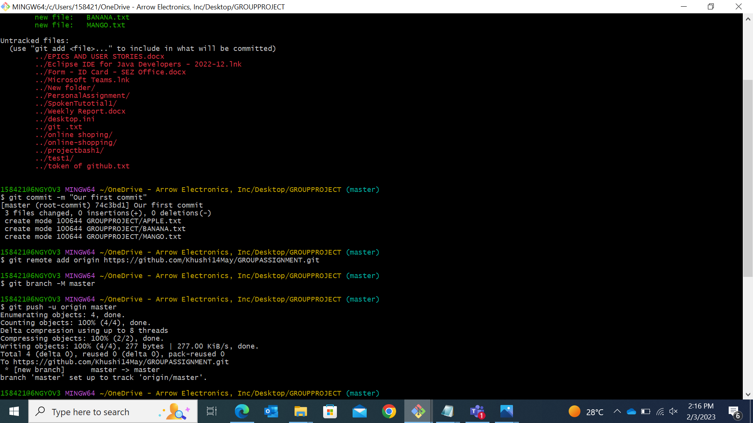

Pushed the files in the github

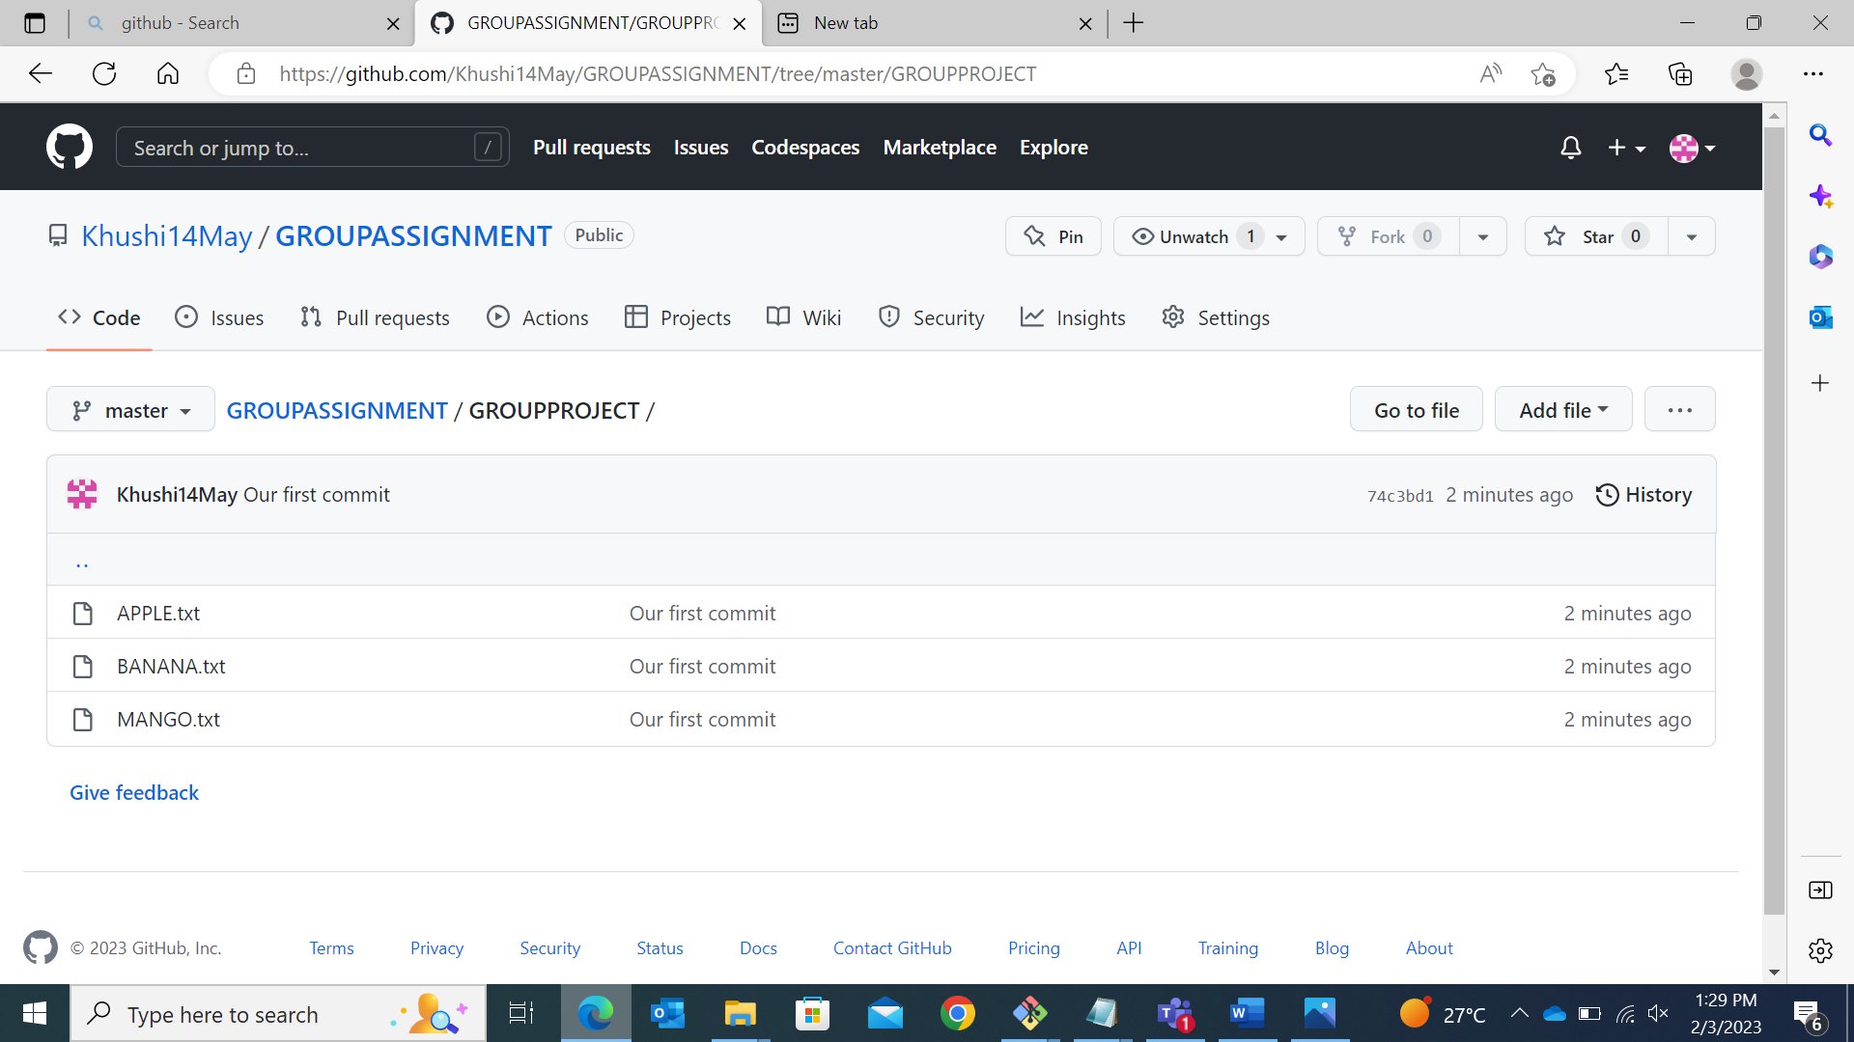

Forked the folder and then cloned it

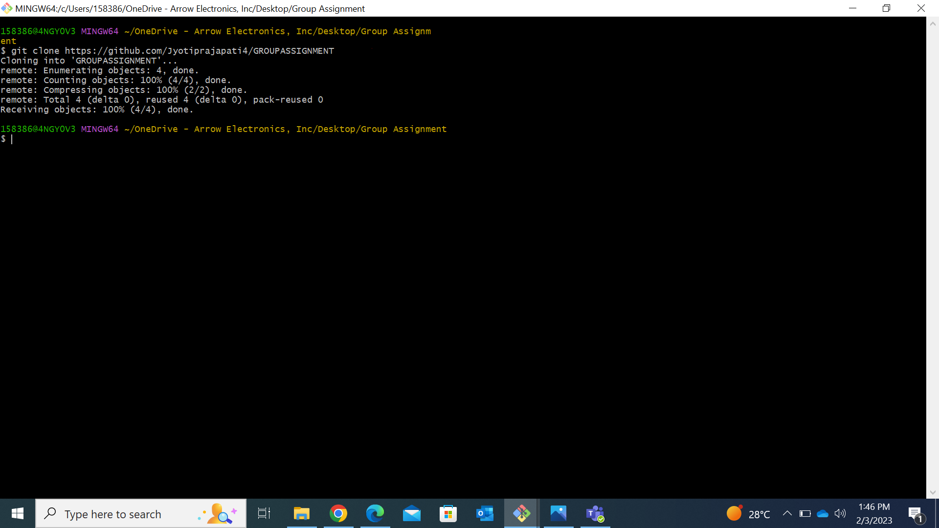

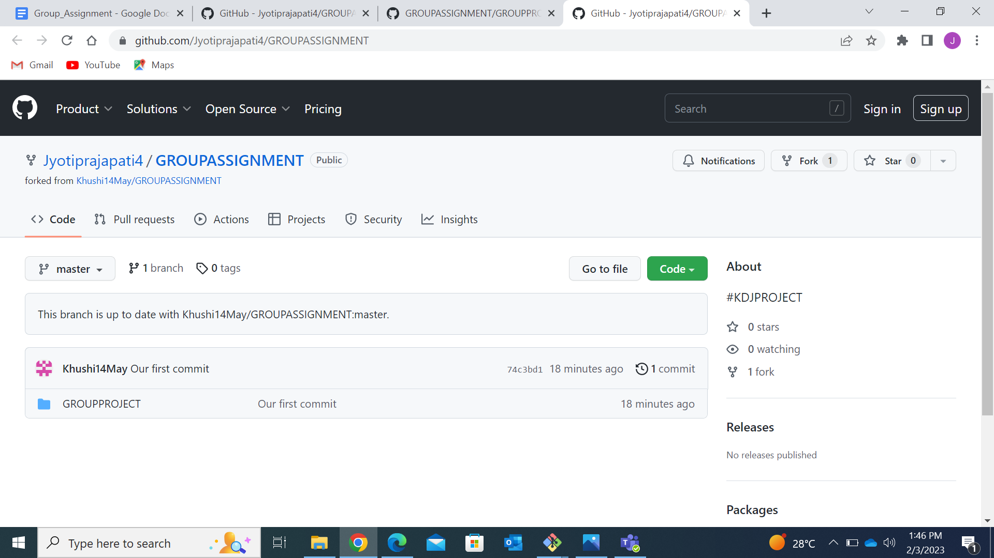

Created new branch (fruits) and create a new file in it

Also pushed the branch in to the github repo

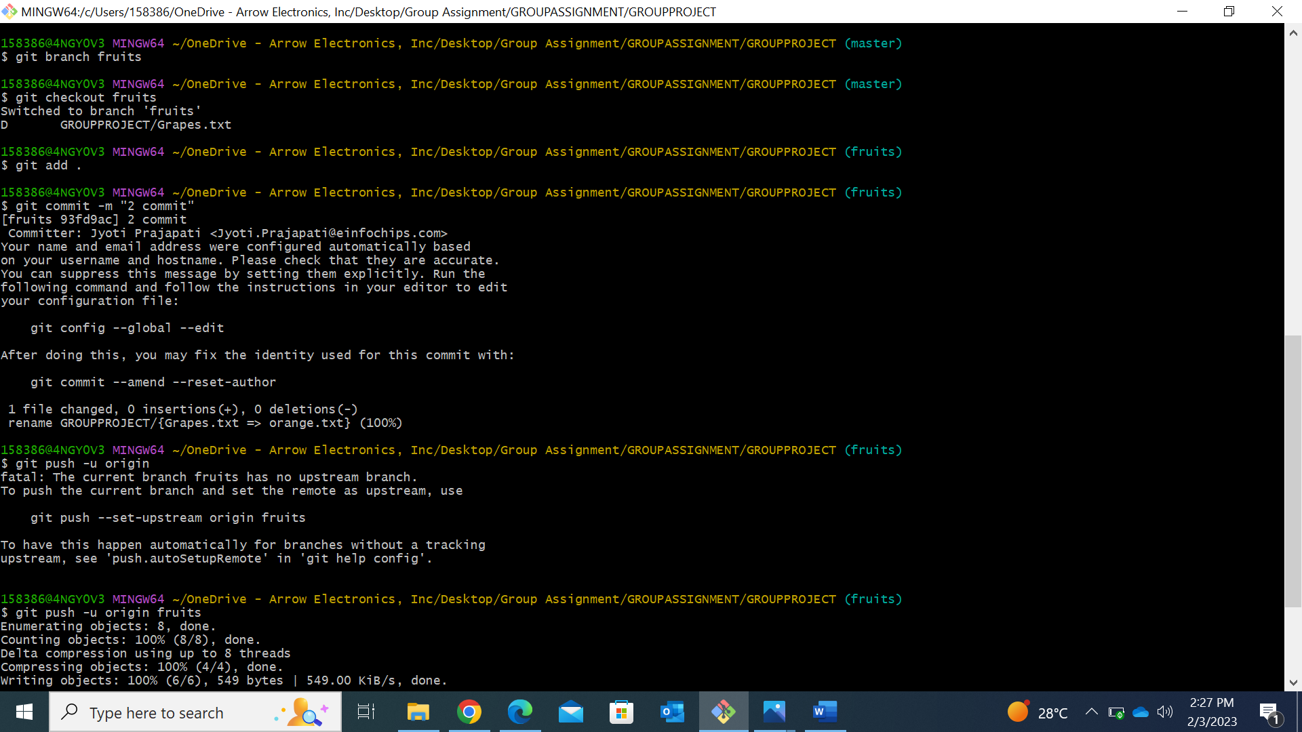

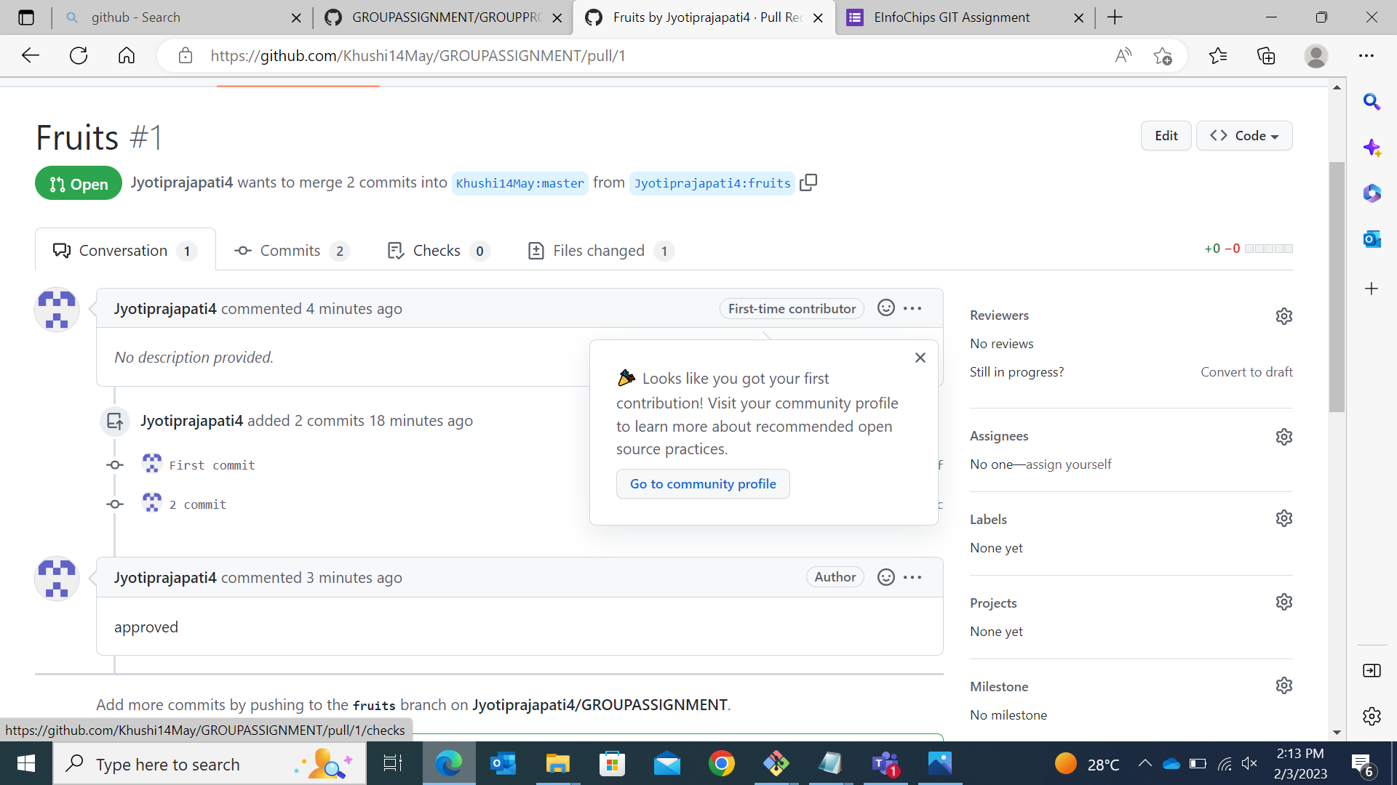

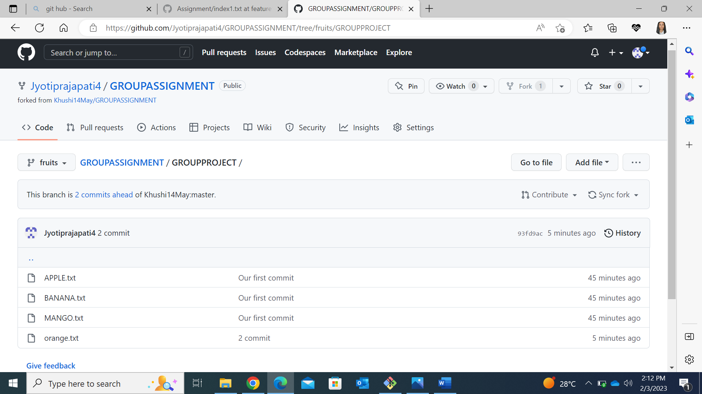

Merged request